上汽安吉物流股份有限公司

项目名称： AABB测试例子

指导老师： 方阳

学生学校： 华中科技大学

学生姓名： 张泽正

完成日期： 2021.8.10

（注：为了可以在panel中作图，作图数据（cmd中显示的数据）=（实际数据+4）*100，单位10mm）

1. COMPACT

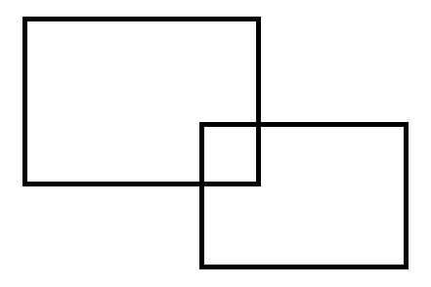

测试1数据：

Cube1:

|  |  |  |  |  |  |  |  |
| --- | --- | --- | --- | --- | --- | --- | --- |
| -2.1 | -0.4 | 2.38527 | -0.4 | 2.38527 | 2.89212 | -2.1 | 2.89212 |
| Cube2:  0 | 1.5 | 5.85 | 1.5 | 5.85 | 4.85 | 0 | 4.85 |

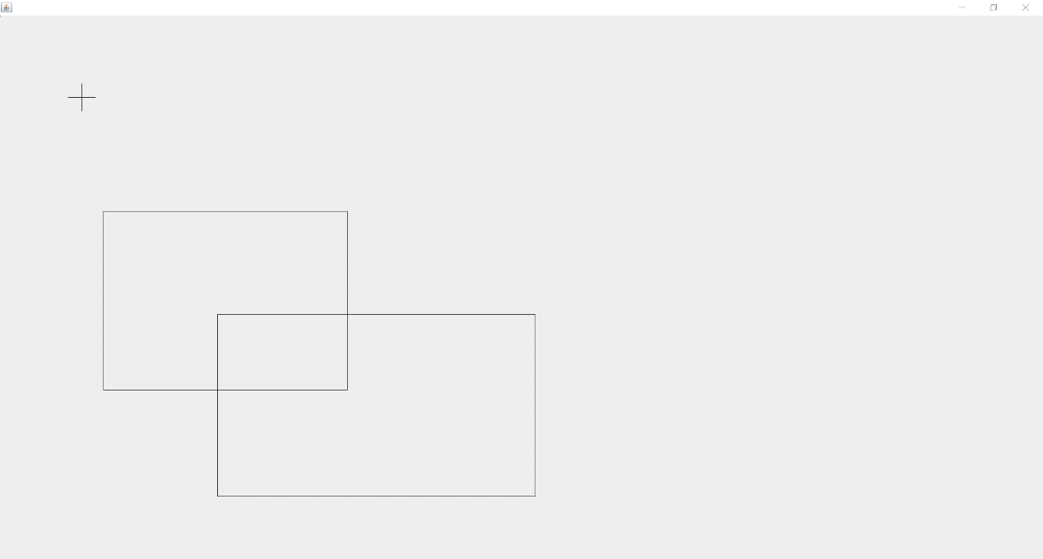

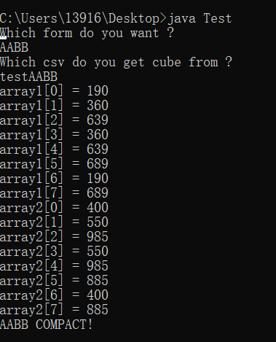

结果：

显示正确

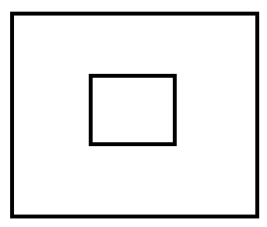

测试2数据：

Cube1:

|  |  |  |  |  |  |  |  |
| --- | --- | --- | --- | --- | --- | --- | --- |
| -2.1 | -0.4 | 2.38527 | -0.4 | 2.38527 | 2.89212 | -2.1 | 2.89212 |
| Cube2:  -3 | -3 | 4.85 | -3 | 4.85 | 4.85 | -3 | 4.85 |

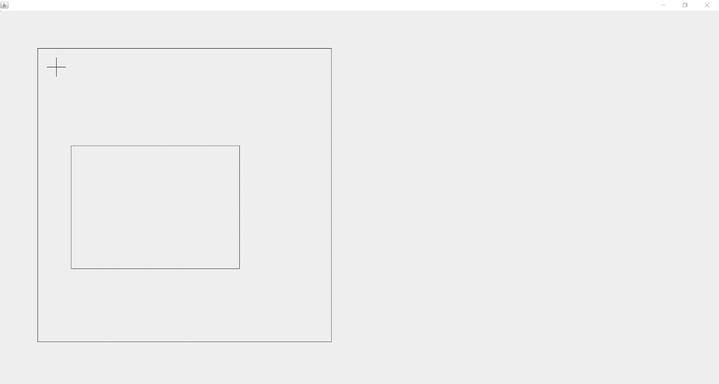

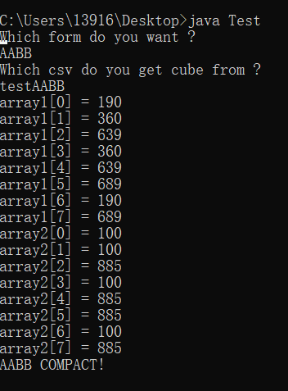

结果：

显示正确

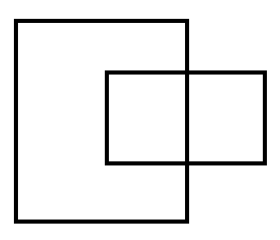

测试3数据：

Cube1:

|  |  |  |  |  |  |  |  |
| --- | --- | --- | --- | --- | --- | --- | --- |
| -1.76 | -0.425 | 5.85 | -0.425 | 5.85 | 4.85 | -1.76 | 4.85 |
| Cube2:  3 | 1 | 7 | 1 | 7 | 3 | 3 | 3 |

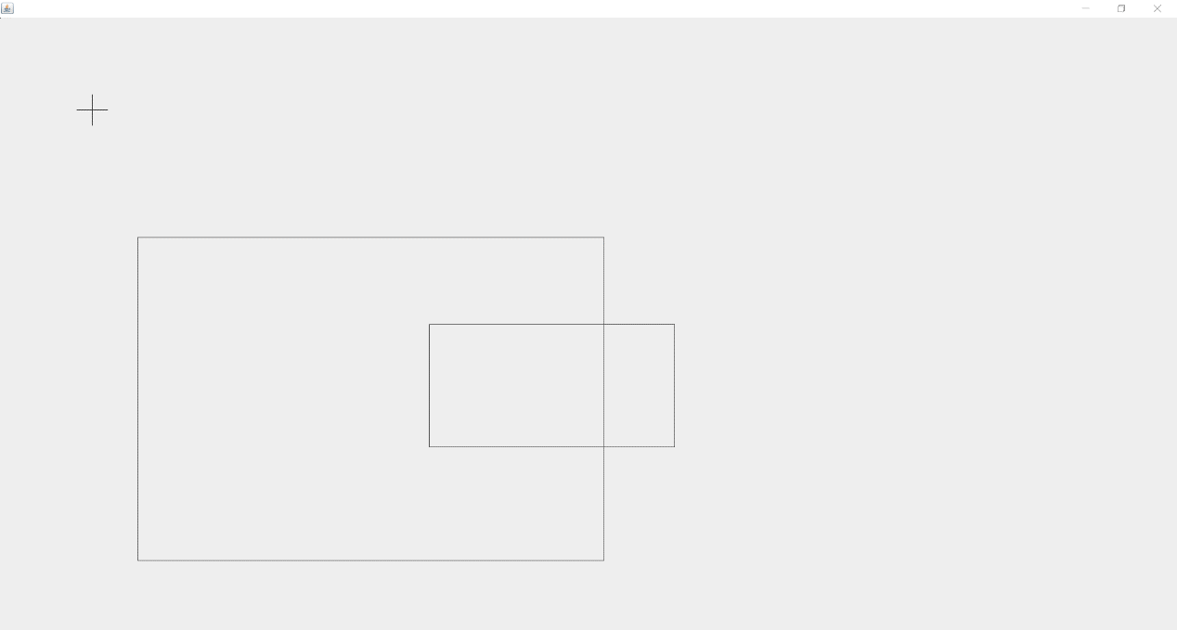

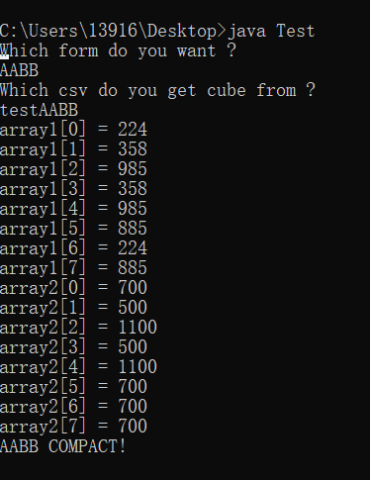

结果：

显示正确

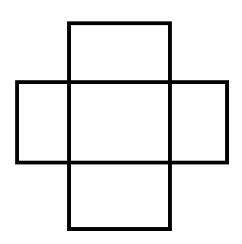

测试4数据：

Cube1:

|  |  |  |  |  |  |  |  |
| --- | --- | --- | --- | --- | --- | --- | --- |
| -1.76 | -0.425 | 5.85 | -0.425 | 5.85 | 4.85 | -1.76 | 4.85 |
| Cube2:  -3 | 1 | 7 | 1 | 7 | 3 | -3 | 3 |

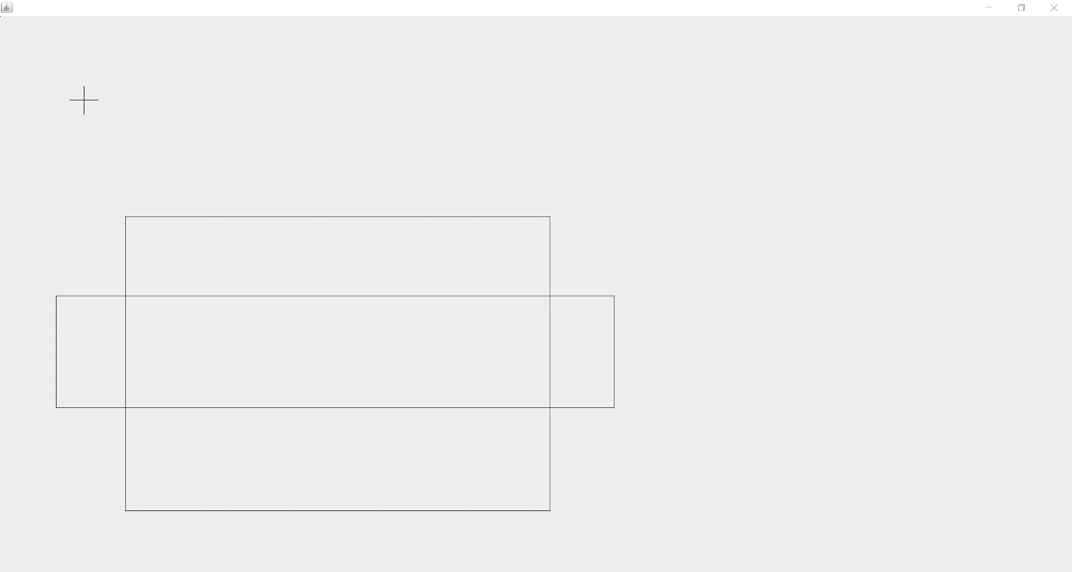

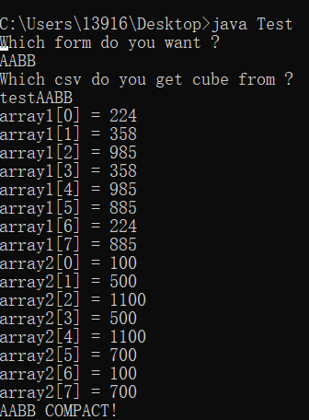

结果：

显示正确

1. DISCOMPACT

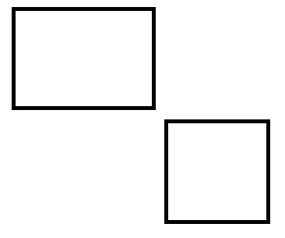

测试1数据：

Cube1:

|  |  |  |  |  |  |  |  |
| --- | --- | --- | --- | --- | --- | --- | --- |
| -2.1 | -0.4 | 2.38527 | -0.4 | 2.38527 | 2.89212 | -2.1 | 2.89212 |
| Cube2:  3.5 | 3.5 | 5 | 3.5 | 5 | 4 | 3.5 | 4 |

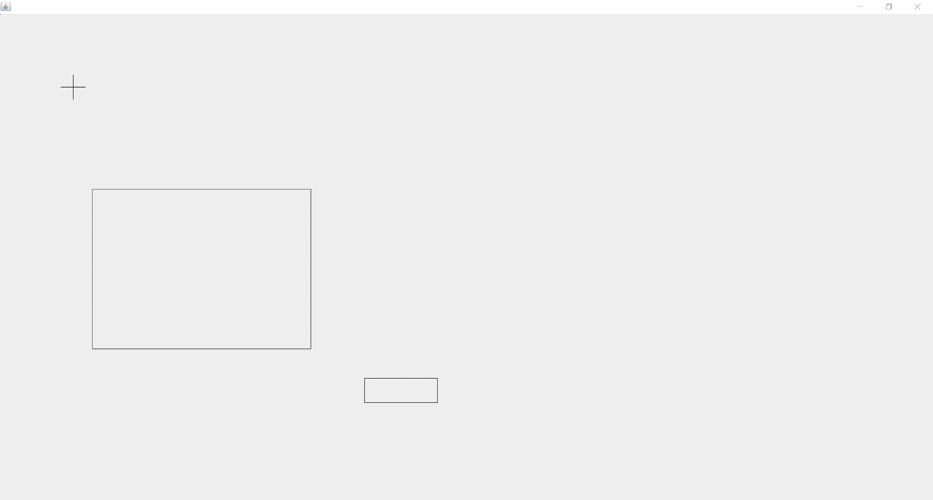

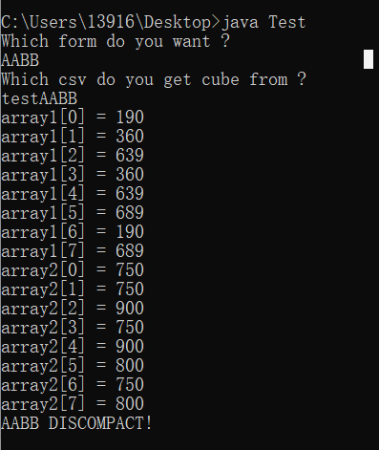

结果：

显示正确

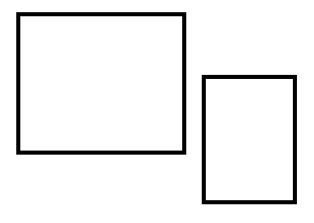

测试2数据：

Cube1:

|  |  |  |  |  |  |  |  |
| --- | --- | --- | --- | --- | --- | --- | --- |
| -2.1 | -0.4 | 2.38527 | -0.4 | 2.38527 | 2.89212 | -2.1 | 2.89212 |
| Cube2:  3 | 1.5 | 5.85 | 1.5 | 5.85 | 4.85 | 3 | 4.85 |

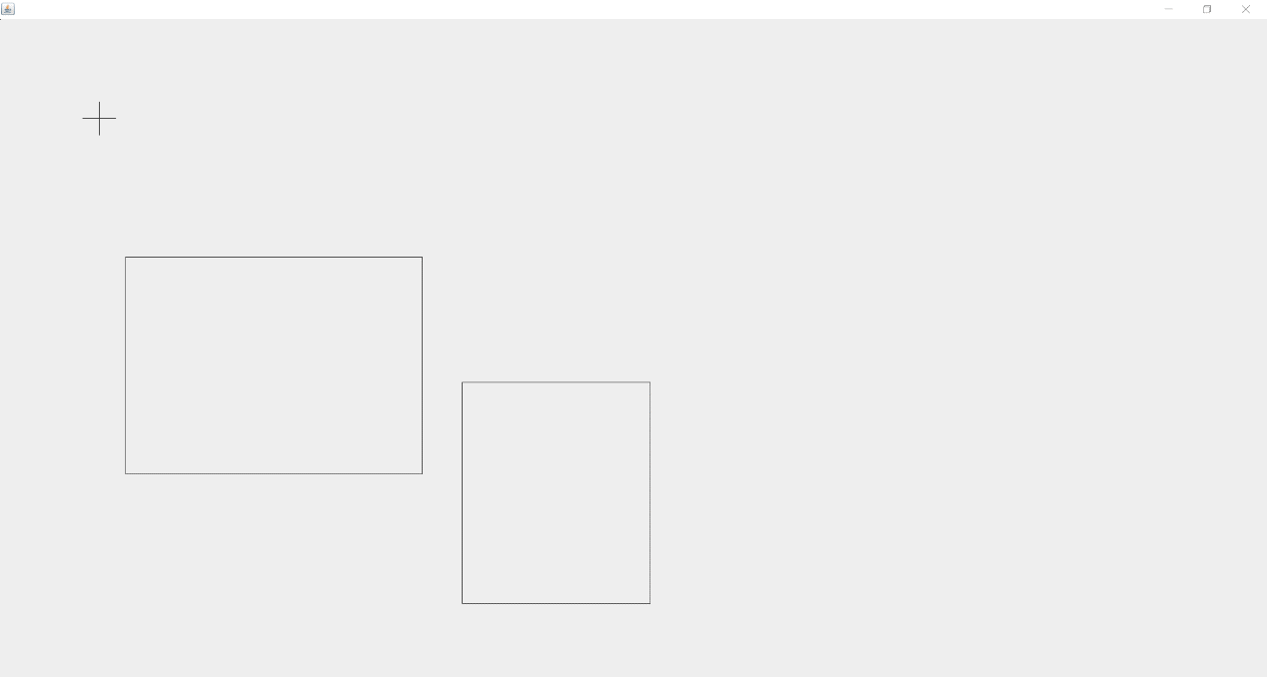

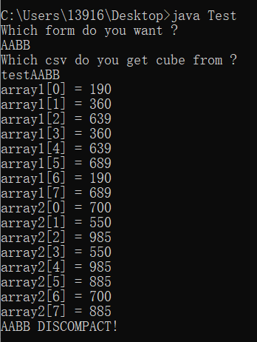

结果：

显示正确

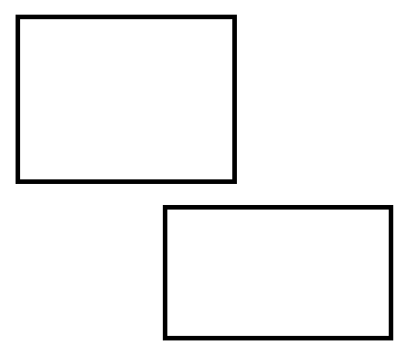

测试3数据：

Cube1:

|  |  |  |  |  |  |  |  |
| --- | --- | --- | --- | --- | --- | --- | --- |
| -2.1 | -0.4 | 2.38527 | -0.4 | 2.38527 | 2.89212 | -2.1 | 2.89212 |
| Cube2:  0 | 3.5 | 5.85 | 3.5 | 5.85 | 4.85 | 0 | 4.85 |

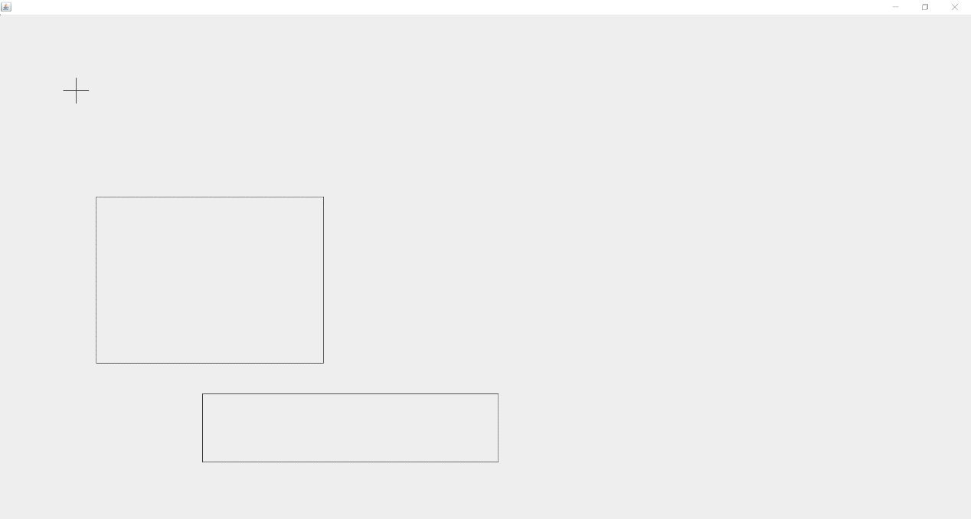

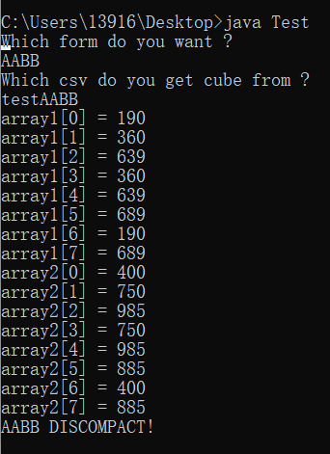

结果：

显示正确

总结：通过测试例子，说明了AABB算法正确。